Service Circular

4 Wheeler

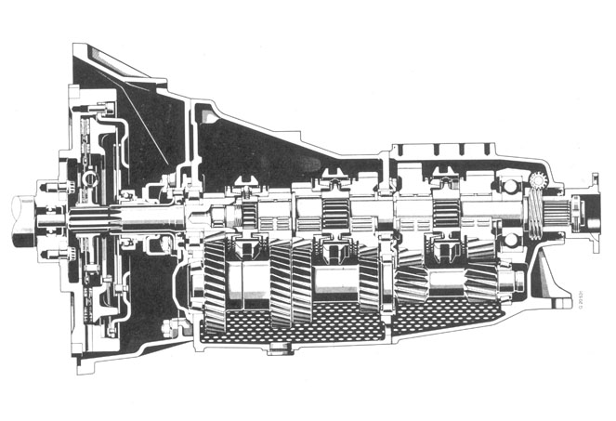
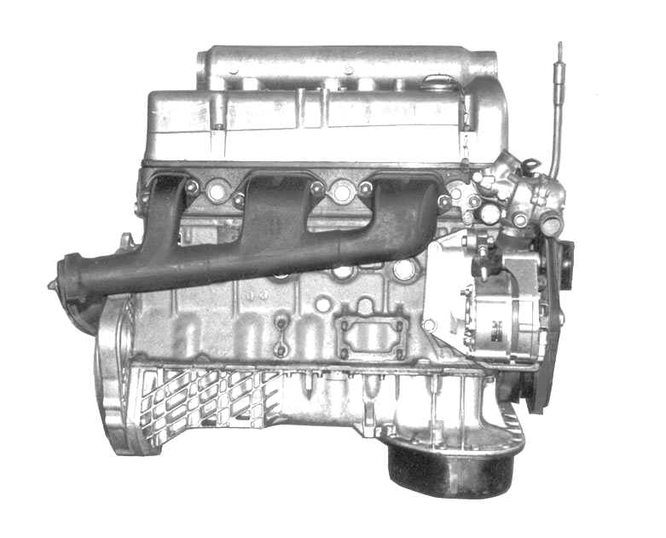

APR-2004


28 Apr, 2004

To,
All Dealers & Field Staff

Service Modification Circular – Engine/Transmission

We are circulating herewith the booklet on Various Modifications implemented on our Four wheelers. This bulletin will give you the clear idea regarding the application of spare parts in relation to the type of vehicle, model & aggregatewise on which the modification has introduced.

The spare parts modification circular will tell you the nature of modification, the reason for modification, the details of new parts introduced with reference to old part Nomenclature. The circular will also indicate the interchangeability of the new parts with old part if any.

The month from which the modification is also indicated in circular.

Sd/- Sd/-
S.V.Shirhattikar V.N. Bellary
(Div.Manager – Service) (Sr.Manager – Service)

