CONFIDENTIAL. 23-09-2003

Circular to all SERVICE ENGINEERS & REGIONAL SERVICE MANAGERS

Sub –Field Inspection of T1 Euro II vehicles for Proper Sealing Of
AIR-FILTER CARTIDGE

We have received stray complaints of in-correct seating of AIR FILTER INSERT In
Air cleaner housing resulting in a gap at filter insert at bottom end sealing.
Please refer to the sketch below,

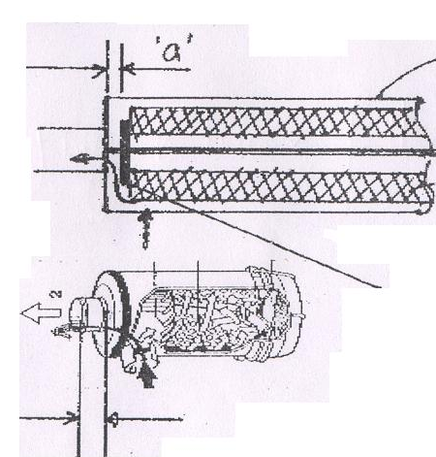
Housing
This rubber seal must be firmly pressed on to the bottom plate of Air cleaner Housing. There should be no gap between the seal & housing plate
This GAP is not permissible

Procedure for checking

1) Remove existing Filter Insert.

2) Apply Carbon glue on rubber sealing face at the bottom end of Filter Insert.

3) Re-assemble insert in housing on the center rod. Firmly tighten the M 12 nut.

4) Again Remove the Insert & ensure that full contact sealing marks are clearly observed on the Housing bottom seating plate.
5) In case you observe incorrect sealing of filter as shown in the sketch above, i.e. gap “a’ is observed then this may cause entry of unfiltered air in the engine Turbo- charger & in the combustion chamber & this will in-turn result in the reducing of the engine life.
6) In such a case you have to replace the filter housing part code no T 00 686 14 00 380 complete, with insert.

You are therefore requested to inspect all T1 Euro II vehicles in your territory ON TOP PRIORITY BASIS & confirm to us, quoting the Chassis no. & engine no., that the sealing of filter Insert is O.K.

Please acknowledge the receipt of this circular by a return communication.

S.V.Shirhattikar. V.N.Bellary.

(Divisional Manager –Service) ( Dy. Manager- Service )

