18 June, 2004

To,
All Field Service Staff,

Sub. : Traveller type front Stub Axle introduced on Tempo Trax
vehicles.

The Tempo Trax Front suspension today carries a very favorable and positive opinion in the market, with improved articulation angle and modified locking arrangement for wheel joint..

A Further enhancement in the construction of the wheel hub assembly, has been introduced, as a means of extreme precaution, to take up unusually arduous, operating conditions as shown in the diagram below.
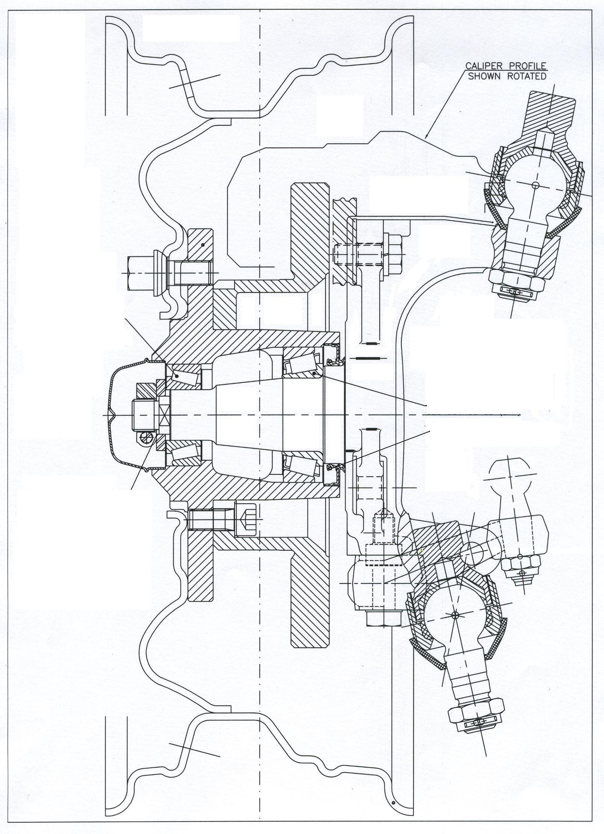

Larger Diameter Inner Bearing –
Outer Bearing –
High Quality, multiple lip, Grease & dust sealing Ring

Wheel Bearing adjusting & locking nut - Conventional arrangement of the outside hub. Collapsible bush arrangement deleted – Chance of Wrong setting of wheel bearing play eliminated

The Wheel hub assembly has been modified to take up larger diameter Inner Taper Roller bearing to specifications 76.2 mm. diameter as compared to earlier 72 mm. The outer bearing remains the same as it is found to be adequate. Accordingly the stub axle & the hub construction also becomes even more sturdy.

Furthermore the stub axle & hub assembly has been modified to the conventional wheel bearing adjusting nut on the outer side of the hub ( like in Tempo Traveller). The facility of grease cup will facilitate periodical greasing requirement’ if any.

Important Assembly Notes :

1) Axial wheel bearing play - 0.04—0.06mm.
2) Use Autoplex Grease NLGI = 2.5 on Bearing of each side of hub. Qty. -
150 gms/hub.

Tightening Torques :

1) Wheel bolt (A 0000 250 20 452) : 16 kçm.
2) Caliper mtg. Bolt (B 00 820 352 00 721) : 11—12.5 kgm.
3) Banjo Bolt (C 915 056 00 61 02) : 5—4 kgm.
4) Bleed screw : 0.5 to 0.8 kgm.(across
flat = 9mm)
5) Guide pin bolt : 5 to 5.5 kgm.(to be
done at vender)
6) Disc mtg.bolt (C 914 125 012 5011) : 11—12.5 kgm.
7) Lock nut screw ( A 0000 912 006 055 ) : 1.7 to 2.2 kgm
8) Steering lever Mtg. Bolt A 0000 901 12 051 : 12kgm

- Pad lining to be free from contamination, should be asbestos free & worn pad condition thickness = 17mm
- Max. Lateral runout of brake disc measured at max. Dia of brake surface = 0.15mm
- LH as shown RH mirror image
- Ensure 182 002 016—1 folding on flat face of bolt to be positive

This modification will result in eliminating, whatever reservations the road-side mechanics had on the earlier arrangement of the adjusting nut on the insides.

This modification thus results in a higher factor of safety, reducing further, any possibility of wheel bearing or a resultant hub failure, even in the most demanding operating conditions.

This is expected to further enhance the life of all the components of front wheel hub assembly.

You will thus notice, that the Tempo Trax Front Suspension with a very sturdy Axle & Hub Assembly, is an extremely durable, reliable & trouble free arrangement.

Please convey this effectively to all the Dealers & Dealers Staff in your territory.

SD/-
S.V.Shirhattikar V.N.Bellary
Div.Manager – Service Manager - Service

