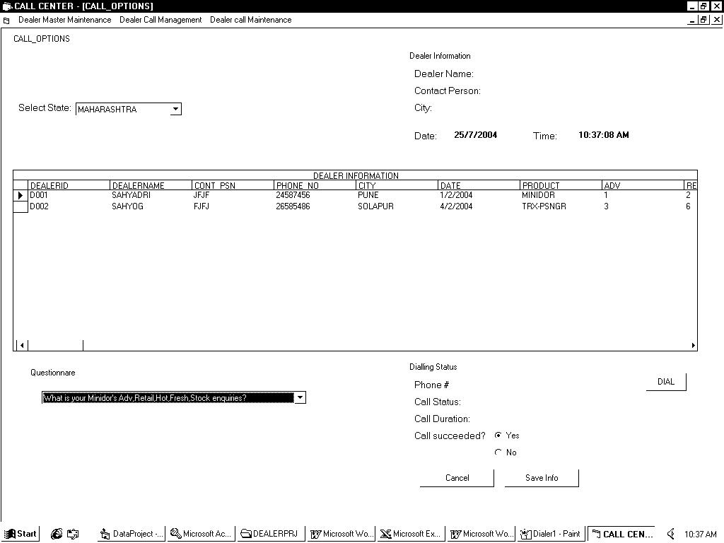

TABLES:

DEALER MASTER:

DEALERID, DEALERNAME, OWNERNAME, CONTPSN, PHONENO, STATE

DAILY CALL TRANSACTIONS:

DEALERID, DATE, PRODUCT, ADV, RETAIL, HOT, FRESH, STOCK

CALL LOG TRANSACTIONS:

DEALERID, DATE, TIME, PHONENO, DURATION

